

SCHOOL OF COMPUTING AND INFORMATICS
DEPARTEMENT OF INFORMATION TECHNOLOGY

TITLE: AGRILINK

STUDENT: Arcel ndala
REG NO: BIT/2024/44434

FIGURE 1:INSTALLATION PROCESS
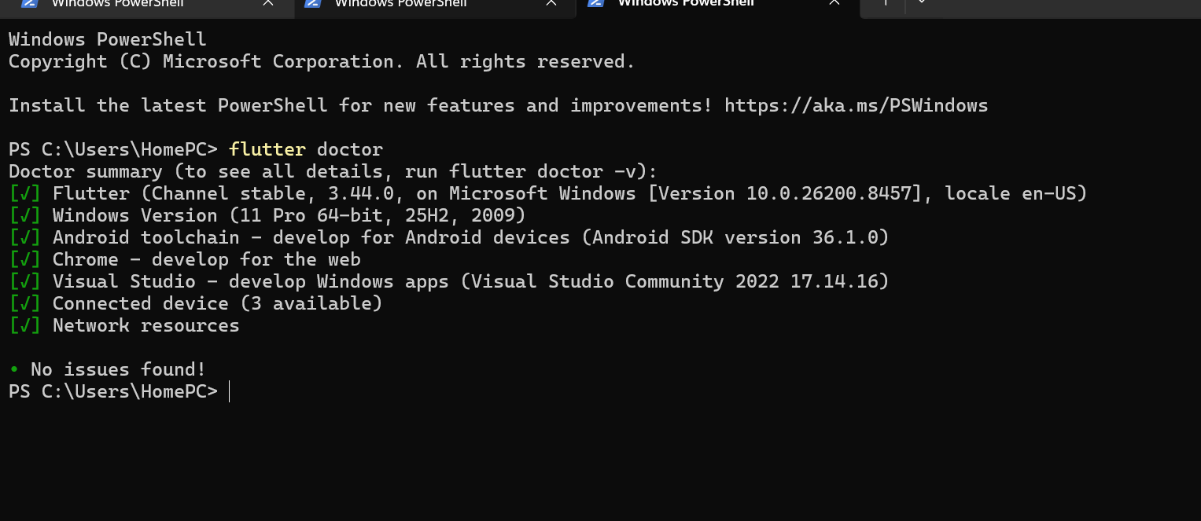

FIG 2: TERMINAL: set the folder structure
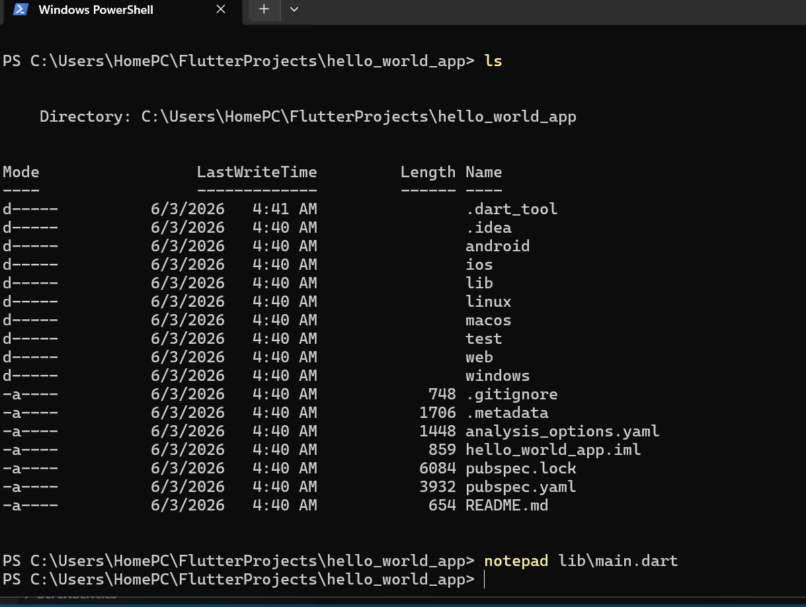

FIG 3: CODES
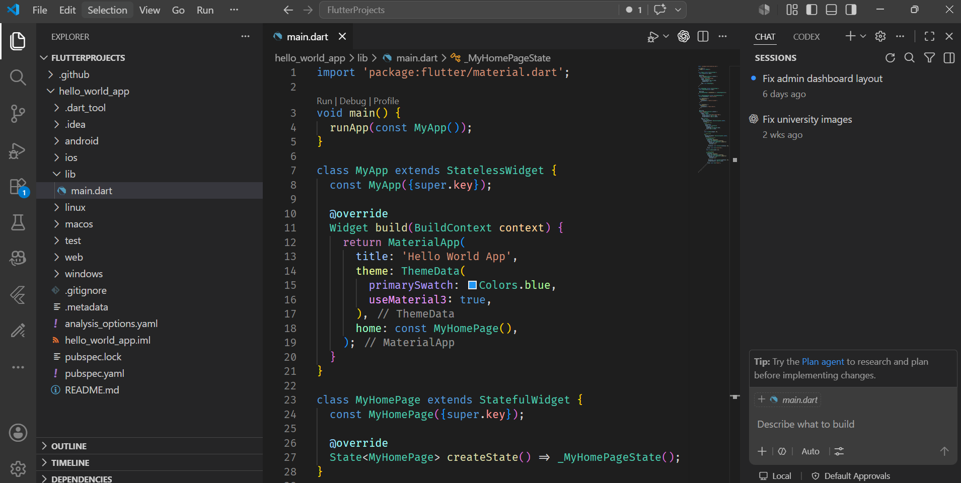

FIG 4:FIRST_APP: display
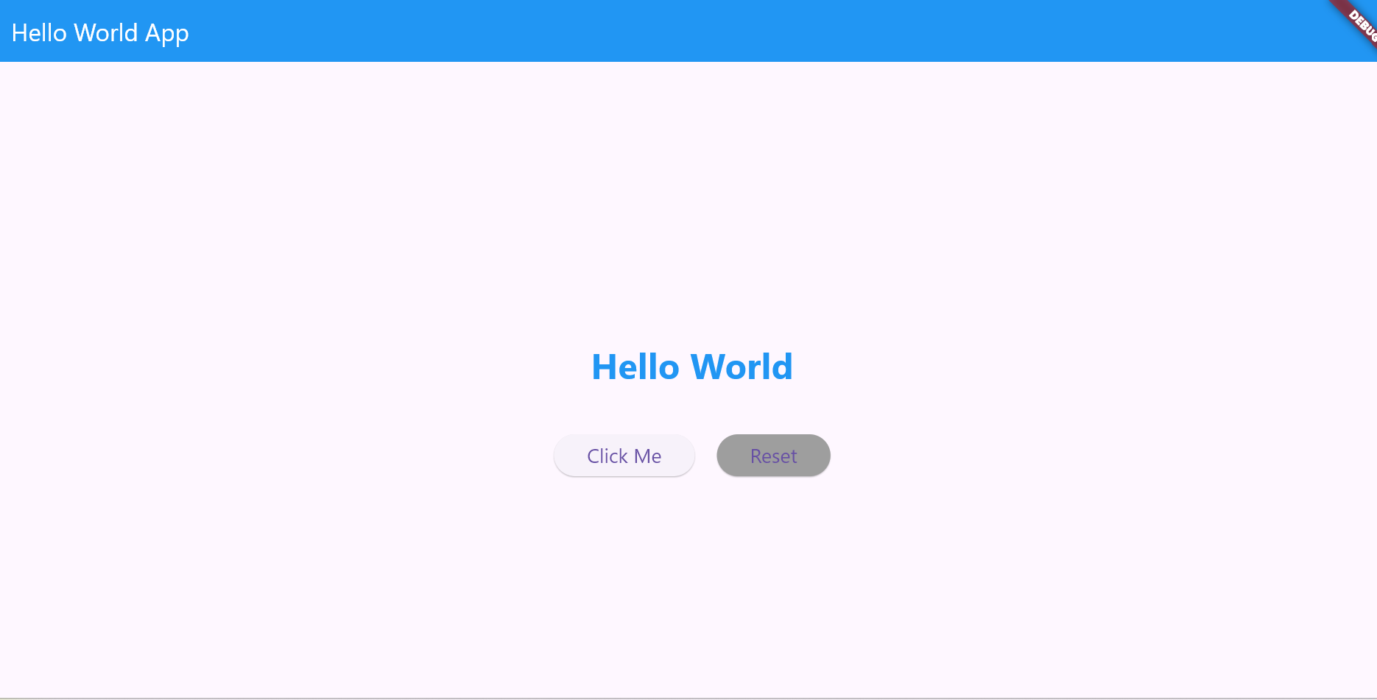
FIG 5:
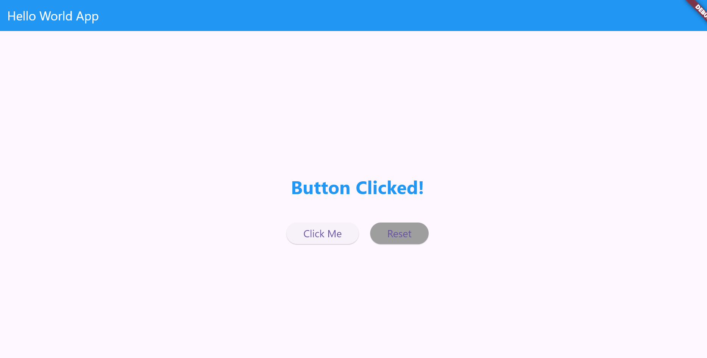
WEEK 2-3. Starting with Building the APP

AgriLink

Home screen
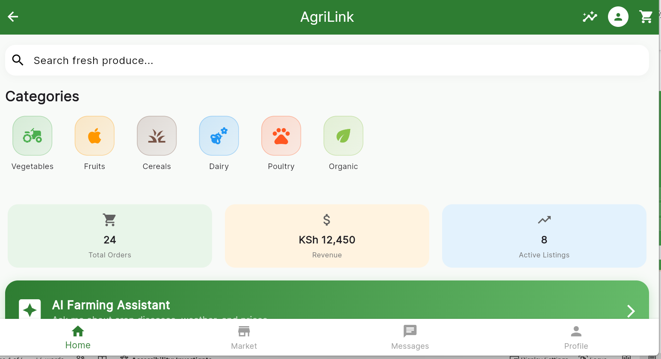

Registration Screen
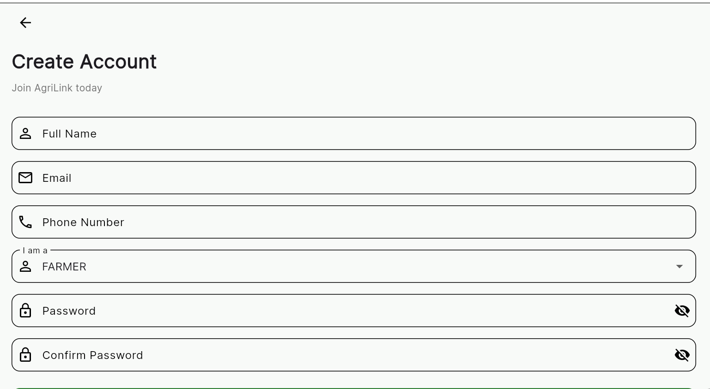

Save records through firebase
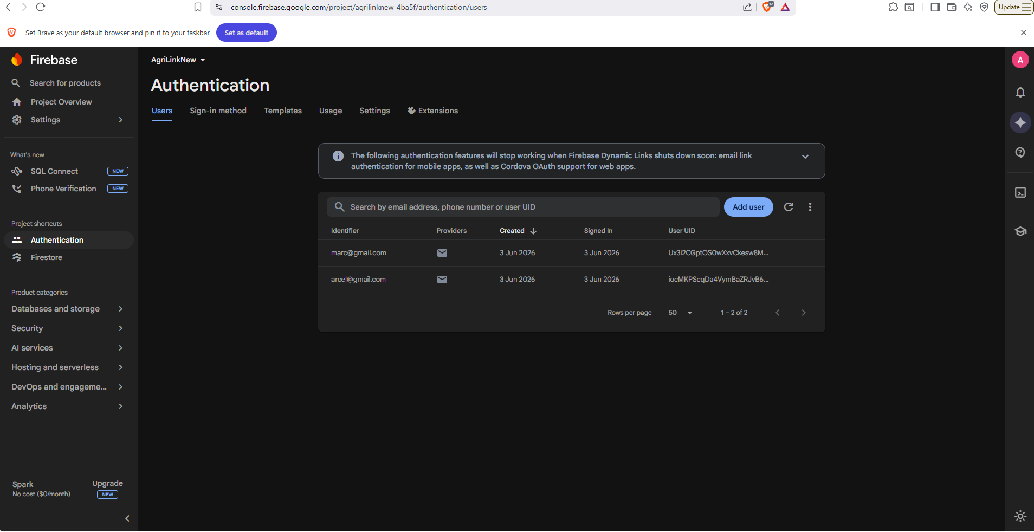

Login Screen

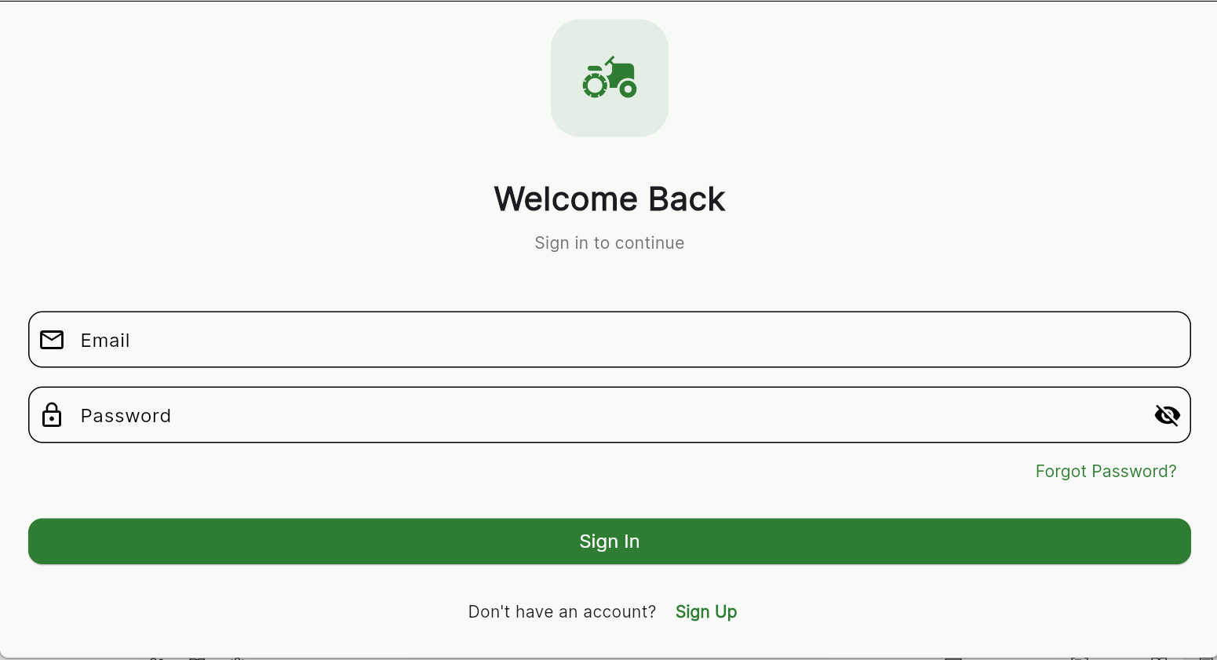

Farmer Dashboard
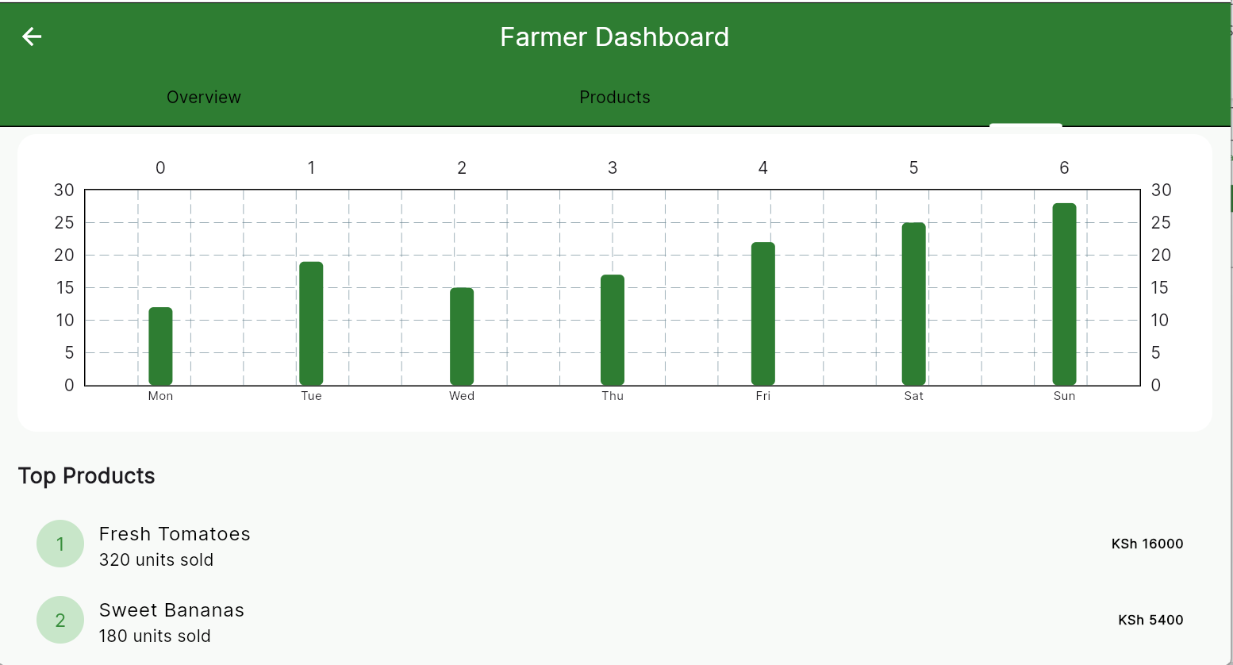

3. Technical Implementation (Weeks 4-5)
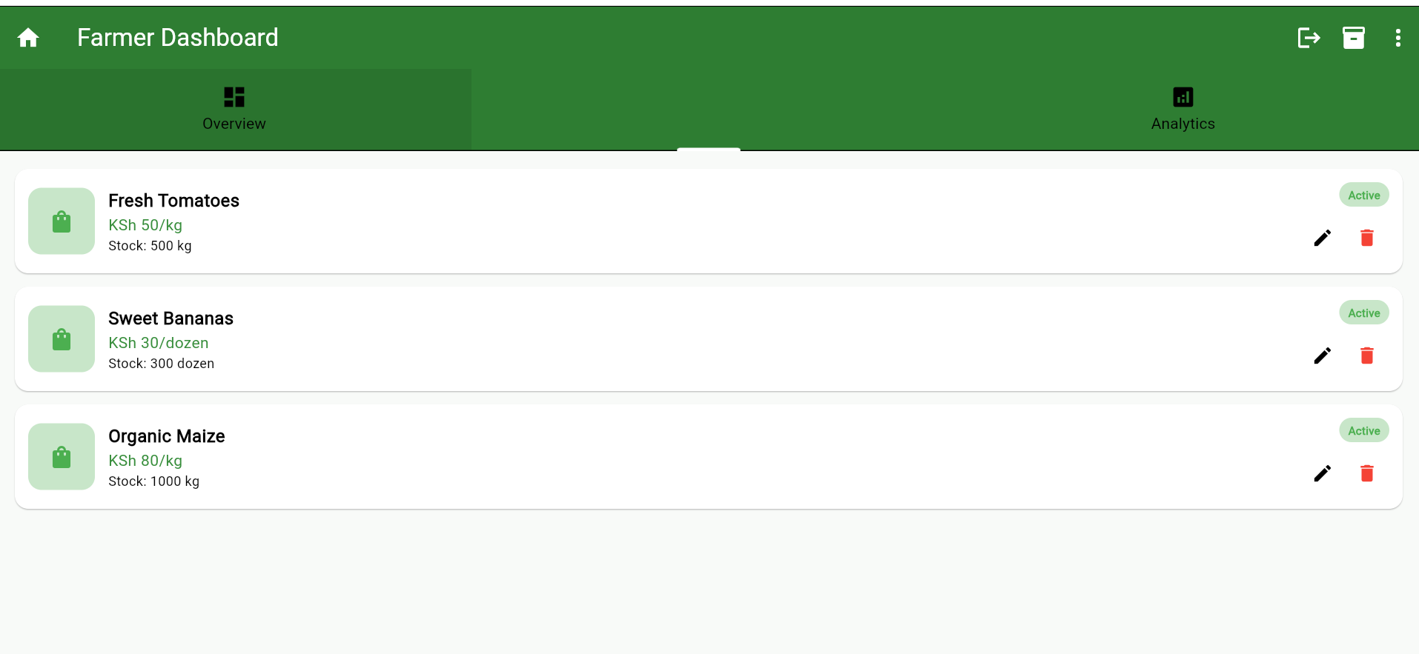
Database integration Using firebase

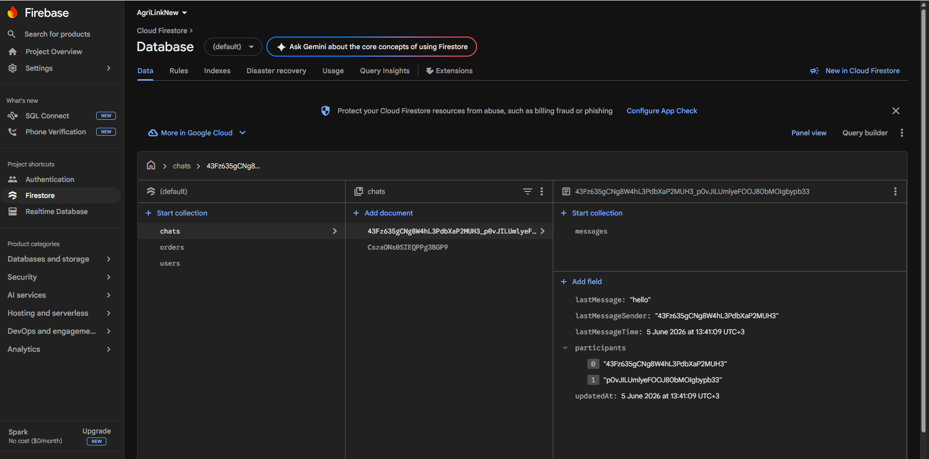

APIs keys
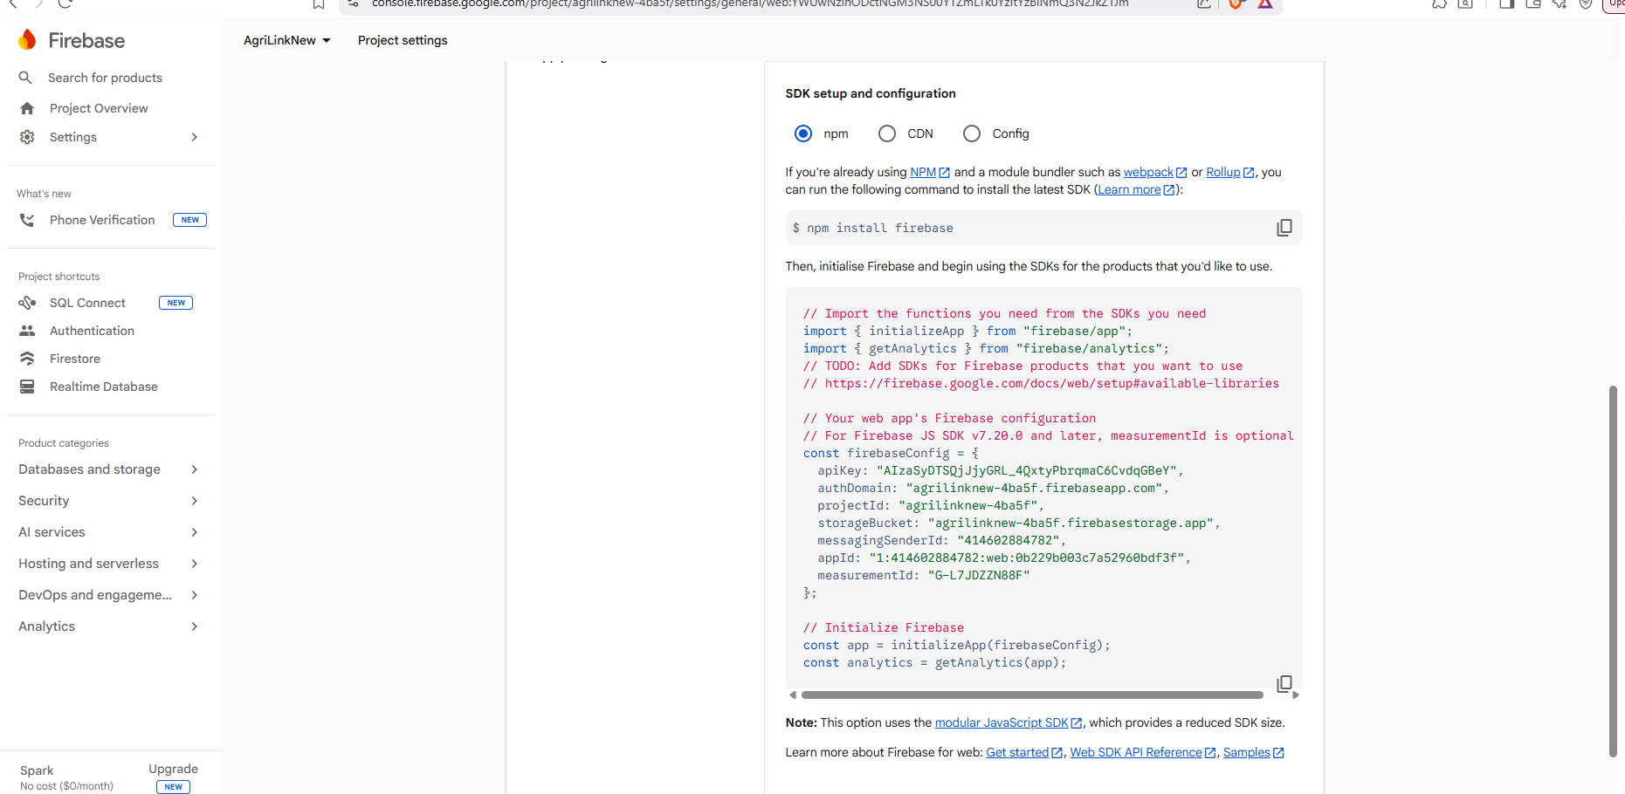
API connection
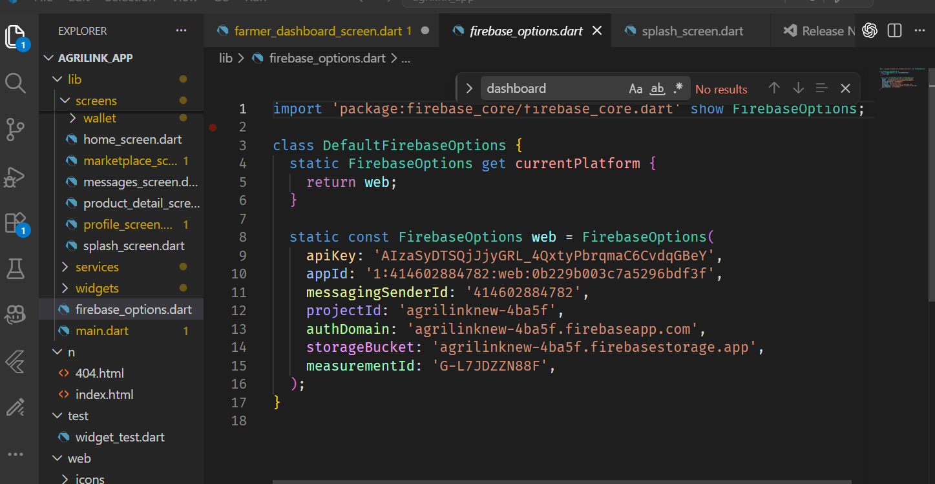

Admin dashboard
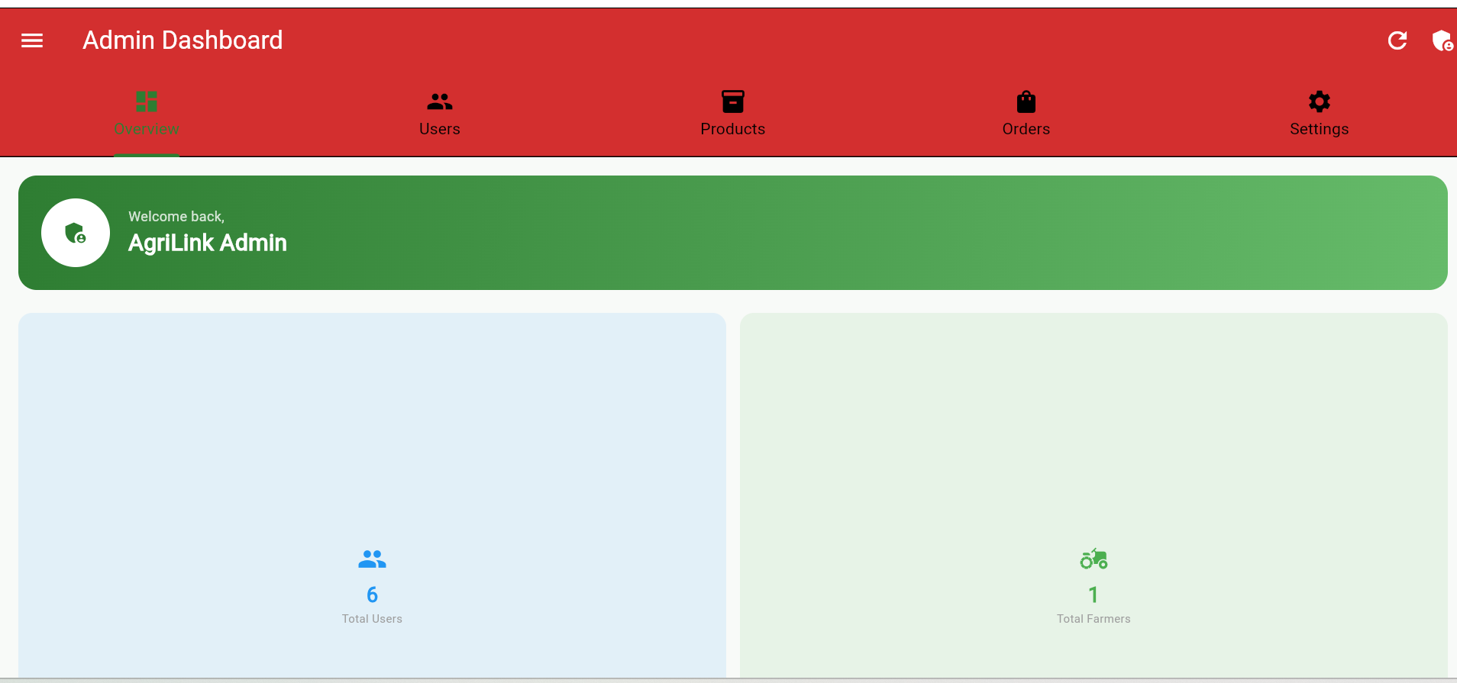

CRUD operations for the admin
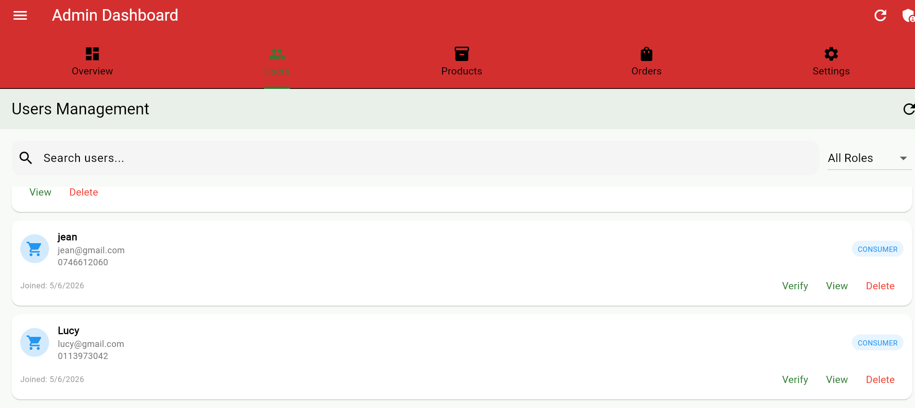
Admin settings
